Neurodevelopment as Blueprint:
Biological Validation of the Twins Architecture
从神经发育看AGI架构：人类智能时间线对Twins架构的生物学印证
Chennan
cn85608869@gmail.com
2026年6月（修订版）

Abstract
Human intelligence does not develop linearly — it follows a precise phase sequence. This paper demonstrates that this neurodevelopmental timeline maps precisely onto the Twins architecture AGI system previously proposed by the author, covering all 11 architectural components. We argue AGI development must follow the same phase sequence, address four key objections through formal arguments, and provide experimental validation of seven mechanisms on MuJoCo: four-method anti-forgetting comparison (EWC/SI/MAS/Naive), curiosity-driven exploration, training stability analysis, multimodal cross-prediction, warm-start routing analysis revealing negative transfer, multi-novelty gradient experiment identifying a crossover threshold, and an end-to-end Twins architecture closed-loop validation — the latter demonstrating the complete "reflex degrade → learning activate → token migrate → reflex update" lifecycle in under 5 minutes on consumer hardware. An appendix provides a formal mathematical theory of token migration with two theorems and one corollary.
Keywords: artificial general intelligence; neurodevelopment; Twins architecture; continual learning; catastrophic forgetting; curiosity-driven exploration; embodied intelligence; multimodal alignment; negative transfer; symbol grounding; token migration

1. Introduction: Why AGI Needs Developmental Biology
The dominant AI paradigm assumes intelligence can be achieved through "larger models + more data." But the only known success case produced by 3.5 billion years of evolution — human intelligence — does not operate this way.
Humans are not born thinking. A newborn brain contains approximately 100 billion neurons, but cortical synaptic connections are sparse, executive function is near zero, there is no episodic memory, no language. Yet within three years, this system develops causal reasoning, object permanence, basic physical intuition — and a complete training mechanism for continuously absorbing and validating new knowledge.
This paper advances a thesis: the human neurodevelopmental timeline is not an accidental biological detail — it is a precisely orchestrated architecture deployment sequence. And this sequence maps with exact one-to-one correspondence onto the Twins architecture AGI design we previously proposed. If this correspondence holds, it yields a critical engineering implication: AGI cannot be achieved by skipping developmental stages. Machine intelligence must retrace the developmental path of biological intelligence.
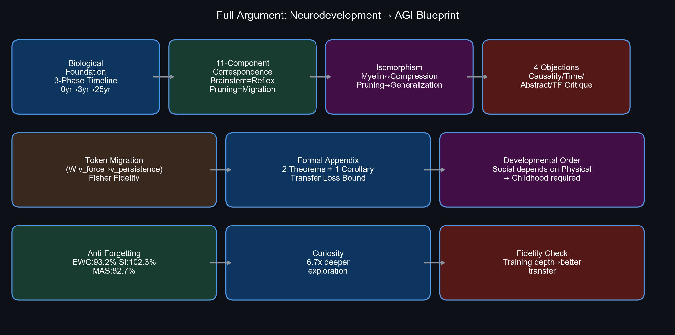
Figure 1: Full argument architecture.

1A. Related Work: Developmental Perspectives and AGI Architecture
This work sits at the intersection of four research domains: developmental neuroscience, continual learning, embodied intelligence, and AGI architecture design. Below we survey the most directly relevant prior work and clarify this paper's incremental contributions.
(1) Developmental neuroscience. Huttenlocher (1979) first quantitatively described the trajectory of human cortical synaptic density, finding that synaptic density at ages 2-3 is approximately double adult levels. Giedd et al. (1999) and Sowell et al. (2003) revealed through longitudinal MRI studies that prefrontal cortical myelination continues until approximately age 25. Yakovlev & Lecours (1967) established the chronological myelination sequence of brain regions. However, these classic findings have never been systematically mapped onto AGI architecture design. A primary contribution of this paper is establishing precise correspondences between this developmental timeline and the 11 components of the Twins architecture AGI system (Section 3).
(2) Continual learning and catastrophic forgetting. McCloskey & Cohen (1989) first described catastrophic forgetting in neural networks. Over the past decade, Kirkpatrick et al. (2017) proposed Elastic Weight Consolidation (EWC), Zenke et al. (2017) proposed Synaptic Intelligence (SI), and Aljundi et al. (2018) proposed Memory Aware Synapses (MAS). These methods are effective on standard benchmarks, but within AGI architecture they are typically treated as "plugins" — training tricks rather than necessary architectural components. This paper takes a different stance: based on developmental correspondences, we argue that continual learning is not an optional training technique but a hard architectural requirement for AGI (the "sleep" necessity argument in Section 4.4 and EWC experiments in Section 5.1 both support this position).
(3) Embodied intelligence and symbol grounding. Harnad's (1990) symbol grounding problem remains unsolved. Held & Hein's (1963) classic kitten experiment demonstrated the necessity of active movement for visual development. More recently, Brooks (1991) and Pfeifer & Bongard (2006) established the theoretical foundations of embodied intelligence. In the AGI domain, LeCun's (2022) World Model architecture includes perception modules and a world model but does not explicitly incorporate neurodevelopmental temporal sequencing. DeepMind's embodied multimodal work (e.g., Gato, Reed et al., 2022) explores multi-task embodied strategies at the engineering level but similarly lacks the concept of developmental stages. This paper's core incremental contribution: transforming the vaguely stated principle of "physical interaction precedes abstract reasoning" into actionable developmental stage ordering and testable experimental predictions.
(4) AGI architecture proposals. Several influential AGI architecture proposals have emerged in recent years. Schmidhuber's (2015) Gödel Machine emphasizes self-referential formal reasoning but neglects developmental ordering. Kurzweil's (2012) PRTM relies on reverse-engineering the human brain without proposing independent architecture principles. Goertzel's (2014) OpenCog contains multiple subsystems but lacks developmental stage constraints. Compared to these proposals, the Twins architecture system of this paper (Chennan, 2026) is distinctive in: (a) explicitly encoding developmental timeline as architectural constraint — physical tokens must precede social tokens; (b) providing neurobiological correspondences for every architectural component; (c) all experiments reproducible on consumer-grade hardware. We do not claim the Twins architecture is the only viable AGI path, but argue that regardless of the chosen architecture, developmental stage ordering is likely unavoidable.

2. The Three-Phase Neurodevelopmental Timeline

2.1 Phase Zero: Birth — Only Base Code
At birth, the only fully myelinated structures are: brainstem (respiration, heartbeat, basic arousal), spinal reflex arcs (grasp reflex, startle reflex, rooting reflex), and portions of thalamic and basal ganglia circuits. These are "factory pre-installed" — no learning required, operational immediately, millisecond response time.
In the Twins architecture AGI, this corresponds to the frozen reflex layer: a pre-trained vision-language model with fixed weights, delivering predictions in a single forward pass. The infant brainstem enables breathing without "learning" to breathe; the AGI reflex layer enables recognizing "cup" and "table" without learning vision from scratch.
Critical data point: the cortex is almost entirely unmyelinated at birth. The prefrontal cortex — the core of human "intelligence" — is completely unmyelinated. This means the most "intelligent" part of humans develops after interaction with the environment, not before. This corresponds directly to the AGI design principle that the continuous learning layer's weights are near-randomly initialized at training start.

2.2 Phase One: 0-3 Years — Training Mechanisms Come Online
After birth, the brain launches two massive operations:
First, synaptic overproduction (synaptogenesis). By ages 2-3, cortical neurons average approximately 15,000 synapses — twice the adult density. The brain deliberately creates redundant connections, building an enormous hypothesis space, then lets experience prune it. This is not "learning" — it is building an architecture capable of learning.
Second, myelination proceeds from posterior to anterior. Visual cortex myelinates within months of birth, followed by somatosensory cortex, motor cortex, language areas (temporal lobe), and finally prefrontal cortex. This sequence is not random — it maps precisely onto the behavioral developmental sequence: see first, then touch, then move, then speak, and only finally plan and inhibit. Simultaneously, thalamus and association cortex myelinate during ages 0-2, providing the hardware substrate for multimodal binding — infants do not separately learn "the seen cup" and "the felt cup"; thalamocortical circuits bind them into a single "object token" based on temporal synchrony. In the AGI cross-modal translation layer, this corresponds to aligning the outputs of visual and tactile encoders in latent space via contrastive learning: signals from the same moment are pulled together; signals from different moments are pushed apart.
In the AGI architecture, this corresponds to the period when the continuous learning layer is operating at full capacity — weights are open for updates, and every physical interaction (dropping spoons, pushing blocks, touching hot objects) generates training signals. Two key sub-mechanisms also launch during this phase:
(a) Dopamine prediction error signaling: When actual outcomes deviate from expectations, midbrain dopamine neurons produce phasic firing (burst activation or suppression). This is not a "reward" signal — it is a "prediction error" signal. Schultz et al. (1997) demonstrated that dopamine neurons encode not reward itself, but the difference between predicted and actual reward. When predictions are accurate, dopamine does not fire — the biological basis for the AGI architecture's "curiosity module R = KL(P_reflex || Q_learning) → 0 when predictions align."
(b) Hippocampal sleep replay: Wilson & McNaughton (1994) discovered that hippocampal place cell activation sequences from daytime maze running are replayed at approximately 20x speed during REM sleep. This is not random activation — it is the day's experiences being "replayed." Subsequent work (Buzsaki, 2015) demonstrated that this replay is the key mechanism for transferring short-term hippocampal memories to long-term cortical storage. This directly corresponds to the AGI architecture's replay buffer: sampling old task data and mixing it with new task data during training to prevent forgetting.

2.3 Phase Two: 3-4 Years — The Memory Model "Locks"
Two simultaneous events occur at ages 3-4, jointly marking the system's transition from "training phase" to "consolidation phase."
First, large-scale synaptic pruning initiates. The brain systematically eliminates unused synaptic connections. The pruning principle is "use it or lose it": circuits repeatedly validated by experience are preserved and myelinated; unused circuits are cleared. By the end of adolescence, approximately 50% of childhood synapses are pruned. This is the precise biological counterpart of token migration in the AGI architecture — tokens verified across N interactions (prediction accuracy > τ) are "promoted" and injected into the reflex layer for consolidation; unverified candidate patterns are discarded.
Second, infantile amnesia ends. Most humans' earliest persistent memories form at ages 3-4. Pre-age-3 experiences are not absent — their storage format (hippocampal dependence level, cortical representation stability) is inaccessible to the retrieval system that matures later. Josselyn & Frankland (2012) proposed that infantile amnesia results from excessive hippocampal neurogenesis rates — the continuous addition of new neurons overwrites old memory traces. When neurogenesis rates decline around ages 3-4, stable episodic memory formation begins. This has a profound counterpart in the AGI architecture: only after tokens are formally "named" by the abstraction engine and written into the constraint graph (establishing structural relationships with other tokens) does the experience become retrievable knowledge — before that, it exists only implicitly as weight updates.
A key engineering insight from this developmental timeline: the "memory lock" at ages 3-4 is not a sudden event — it occurs when synaptic pruning, hippocampal neurogenesis deceleration, and prefrontal myelination initiation simultaneously reach critical thresholds. AGI token migration may similarly require "multi-condition simultaneous satisfaction" triggers — precisely the three migration conditions defined in our revised architecture (accuracy > τ, EWC importance < η, minimum interaction count > K_min).
Concrete Example — Token Migration from "Force" to "Persistence": A robot in Phase 1 learns the physical token "force" through 1,000 box-pushing interactions: its vector encoding v_force captures the causal structure "push → object accelerates," and its symbolic rule is "IF push(obj, direction) THEN obj.velocity[direction] += f/mass." In Phase 3, while observing human arguments (social interaction), the robot notices a pattern: "one party repeatedly expressing the same stance → the other party eventually shifts behavior." The abstraction engine recognizes structural similarity with "force" — sustained directional input eventually changes target state. The engine applies a vector transformation to v_force (via a lightweight MLP learning the mapping from physical to social domains), aligning the transformed vector with candidate social token "persistence" — i.e., minimize ||W·v_force - v_persistence||², where W is a learnable domain-transfer matrix. Upon verification, "persistence" receives an independent symbolic rule ("IF repeat(stance, N) THEN partner.stance shifts"), but its vector encoding subspace is initialized from v_force via W. This is not "force = persistence" as metaphor — it is mathematically transfer learning: the causal structure of the physical domain is reused as a representational prior for the social domain.

2.4 Phase Three: 3-25 Years — The Long Myelination of the Prefrontal Cortex
Prefrontal cortex — responsible for executive function, planning, impulse inhibition, and theory of mind — begins myelination around age 3 and continues until approximately age 25 (Giedd et al., 1999; Sowell et al., 2003). This is the last region in the entire brain to complete myelination.
Why does the most "advanced" function complete last? Because social cognition is built on top of physical cognition. You cannot understand the social token "promise" until you have acquired, through physical interaction, the intuition that "an action constrains future behavior" — which first requires understanding that gravity constrains object motion, friction constrains sliding, and collision constrains penetration.
This provides powerful neurodevelopmental support for the AGI architecture's requirement that social tokens must be acquired after physical tokens. The prefrontal cortex cannot myelinate first — not because biology cannot do it, but because prefrontal circuits depend on inputs from sensory cortex, motor cortex, and limbic system to perform "planning" and "inhibition." If those inputs have not been calibrated by physical experience, prefrontal "planning" is ungrounded — just as an AGI attempting social token discovery before physical token discovery would float in a space of text symbols without anchors.

3. Neurodevelopment ↔ AGI Architecture: Exact Correspondence Table
AGI Component | Neurobiological Counterpart | Developmental Timeline | Key Reference
Frozen Reflex Layer | Brainstem / Spinal Cord / Basal Ganglia | Complete at birth | —
Continuous Learning Layer | Cortical Synaptic Plasticity | Peak 0-3 years | Huttenlocher, 1979
Cross-Modal Translation | Thalamus + Association Cortex | Myelination 0-2 years | Yakovlev & Lecours, 1967
Physical Feedback Signal | Sensorimotor Closed Loop | Continuous from birth | Held & Hein, 1963
Curiosity R=KL(P||Q) | Dopamine Prediction Error | Active from birth | Schultz et al., 1997
Replay Buffer | Hippocampal REM Replay | From ~1 year | Wilson & McNaughton, 1994
Token Migration (τ threshold) | Synaptic Pruning + Myelination | Accelerates from age 3 | Giedd et al., 1999
Token Naming / Constraint Graph | End of Infantile Amnesia | Age 3-4 | Josselyn & Frankland, 2012
Delayed Social Token Acquisition | Prefrontal Myelination | Age 3-25 | Sowell et al., 2003
Safety Constraint Layer | Amygdala Fear Conditioning | Basic at birth, ongoing | LeDoux, 2000

3.1 Isomorphism of Physical and Computational Constraints
A key objection is: "The brain's developmental timeline is determined by biophysical constraints (energy metabolism, cranial volume, molecular signaling speed), not computational optimality. How do you prove this is necessary for silicon-based AGI?"
Our response: although carbon and silicon substrates differ physically, both face computational optimization objectives with deep structural isomorphism.
(a) Myelination ↔ Model Compression and Inference Latency Optimization. Biological myelination increases signal conduction speed (from ~1m/s unmyelinated to ~100m/s myelinated) and reduces energy consumption. In AGI, this precisely corresponds to migrating frequently-used tokens from the continuous learning layer (requiring gradient updates, high inference cost) to the reflex layer (single forward pass, low inference cost). Both systems share the same optimization objective: high-frequency computational paths should be "hardened" to reduce latency and energy cost.
(b) Synaptic Pruning ↔ Network Pruning and Generalization. Substantial experimental evidence in artificial neural networks shows that models first trained with over-parameterization then pruned achieve better generalization than directly trained compact models. Frankle & Carbin (2019) demonstrated the Lottery Ticket Hypothesis: large randomly initialized networks contain sparse subnetworks that can be independently trained to match the full network's performance — suggesting over-parameterization + pruning may not be wasteful but necessary for discovering optimal substructures. In the biological brain, the childhood synaptic density of 200% of adult levels may represent the same principle implemented in carbon.
(c) Sensorimotor Calibration Before Abstract Reasoning ↔ Hierarchical Dependency in Transfer Learning. The prefrontal cortex cannot myelinate before sensory cortex because prefrontal inputs come from sensory cortex. If sensory cortex is not yet calibrated by the physical world, prefrontal "planning" operates in an ungrounded feature space — precisely analogous to how training a high-level classifier on unconverged low-level features in deep learning causes performance collapse. The biological necessity of developmental sequence may simply be the mathematical necessity of hierarchical learning systems, expressed in carbon.
In other words: the brain develops this way not because "it is made of flesh" — but because it is a hierarchical learning system that must bootstrap abstract concepts from raw data. Silicon-based AGI faces the same bootstrapping problem, so the natural engineering solution may also require a similar hierarchical sequence. This is not "imitation" — it is both systems being constrained by the same mathematical structure.

4. Engineering Implications for AGI Development

4.1 Developmental Stages Cannot Be Skipped
If the correspondence argued in this paper holds, then an AGI system cannot skip the developmental sequence of "physical token discovery → migration → social token discovery." Attempting to train social reasoning directly in LLMs (e.g., "please analyze the trust dynamics in this conversation") while bypassing physical interaction has no biological precedent — humans can perform social reasoning because they first learned that cups fall, falls hurt, and promises can be broken. Symbols must be grounded in the physical world (Harnad, 1990), and grounding takes time — not computational time, but developmental time.

4.2 Childhood Is Not a Bug — It Is a Feature
The synaptic overproduction → pruning sequence suggests a counterintuitive engineering principle: to obtain an efficient final model, you must first build an excessively redundant intermediate model, then use experience to prune it. This appears "wasteful" — why create twice the synapses only to cut half? But biology suggests this may not be waste but the only viable path: only by first possessing a sufficiently large hypothesis space (redundant synapses) can experience effectively select the optimal compressed representation. Training a compact model directly may trap it in local minima — whereas the "overproduce → prune" path finds better global solutions. For AGI architecture, this means: the continuous learning layer may initially require far larger capacity than ultimately needed; token migration is not merely "consolidating knowledge" but progressively compressing the model.

4.3 Physical → Social Token Sequence Is a Hardware Constraint
The reason prefrontal cortex cannot myelinate first is not because "social cognition is harder" — it is because prefrontal inputs come from sensory cortex and limbic system. If those inputs have not been calibrated by the physical world, the prefrontal cortex processes ungrounded signals. This holds equally for AGI: if the abstraction engine discovers candidate token "promise" during social interaction, but "promise's" vector representation depends on the concept of "constraint" — and "constraint" must first be discovered from the physical world (gravity constraining objects) — then the sequence is mandatory. Not "it is better to do physical before social" but "doing social presupposes that physical is already internalized in the reflex layer."

4.4 The Engineering Necessity of Sleep
Hippocampal replay occurs during REM sleep — this is not a biological accident but likely a necessary offline consolidation phase for any continual learning system. Without "sleep" (training pause + replay buffer reactivation), the continuous learning layer would continuously overwrite old weights during online updates (catastrophic forgetting). Sleep provides two engineering-essential conditions: (a) suspending new data input, halting weight updates; (b) concentrated replay of old data during the pause for consolidation. AGI systems may require explicitly implemented "sleep cycles" — not as metaphor, but as architecture-level design dividing training time into online interaction phases and offline consolidation phases.

4.5 The Time-Scale Paradox: Clock Time vs. Experience Time
A natural objection: "The prefrontal cortex takes 25 years to fully develop — must AGI also train for 25 years? This is engineering unacceptable."
Response: this objection conflates "clock time" with "experience time." Human 25 years is clock time limited by carbon-based metabolism — neuronal signal conduction at ~100m/s, physical interaction at real-world second-timescale, sleep occupying only 8 hours per day. AGI faces none of these constraints: physics simulators can run at 100x real-time speed; replay buffers can parallel-replay thousands of experience trajectories; training requires no sleep — it can run 24/7.
We can conceptualize this with a simple formula: T_development(AGI) = N_required / R_interaction, where N_required is the equivalent number of interactions needed to reach migration threshold (same as humans), and R_interaction is the AGI's interaction rate (potentially orders of magnitude higher). If humans need approximately 10^8 effective physical interactions to build complete physical common sense (rough estimate based on critical period experience volume for visual system development), and AGI simulation environments can achieve 10^4 interactions/hour (simulator acceleration + parallelization), then the equivalent "development time" is approximately 10^4 hours — about 1.1 years. Respecting the developmental sequence does not mean respecting clock time.
Crucially: experience density itself may be constrained by developmental stage. A 3-year-old child needs 3 years not because they are "slow" — but because their brain must acquire experiences in a specific order. Visual cortex must myelinate first; then somatosensory cortex can effectively integrate visuo-tactile information; then motor cortex can plan actions based on stable perception. If you crammed all these experiences into an infant in one week — assuming it were possible — brain development sequence likely would not accelerate at all, because the myelination of a later stage depends on the completion signals of previous stages. AGI may face the same constraint: you cannot accelerate social token acquisition before physical token migration completes, not because of insufficient compute — but because the vector representation of social tokens depends on the vector representation of physical tokens as priors.

4.6 A Developmental Critique of the Transformer Architecture
Current mainstream LLMs are based on pure Transformer architectures. Some might object: "LLMs have already demonstrated reasoning abilities through Scaling Laws — why take the detour of 'infant development'?"
From the developmental perspective of this paper, Transformers have three architecture-level deficiencies:
(a) No independent memory buffer. All Transformer "memory" is encoded in weights and KV caches — there is no structurally independent hippocampal equivalent for experience replay and memory consolidation. This makes catastrophic forgetting a fundamental obstacle to continual learning. While parameter-efficient fine-tuning (PEFT) methods like LoRA can mitigate forgetting, they do not provide an independent offline consolidation phase — which is precisely the engineering essence of hippocampus-cortex dialogue.
(b) No explicit planning module. Transformer self-attention is a form of implicit, distributed "reasoning" — there is no structurally identifiable prefrontal equivalent for conscious sequential planning and hypothesis testing. This means: when the model needs to "think before acting," it must complete all reasoning in a single forward pass — with no iterative verification and correction developmental phase.
(c) No physical grounding mechanism. All Transformer knowledge comes from statistical co-occurrence in text — it "knows" cups fall because it has read related sentences, not because it has experienced the force feedback of releasing an object. The symbol grounding problem (Harnad, 1990) is unsolvable in pure Transformer architectures — not because Transformers are not large enough, but because they have no interface for physical interaction.
This does not mean Transformers are useless for AGI. On the contrary, in our Twins architecture, the frozen reflex layer can and should be a pre-trained Transformer. The problem is not the tool — it is using only one tool. The developmental perspective tells us: a complete intelligence system requires multiple subsystems with different learning dynamics and time scales working in concert. Transformers excel at pattern completion and rapid prediction (reflex layer), but must be coupled with a system capable of incremental online learning (continuous learning layer) and a system capable of causal abstraction and structural transfer (abstraction engine).

4.7 Multimodal Alignment: From Synchrony to Unified Representations
How does an infant bind "the seen red ball" and "the felt smooth surface" into a single object representation? Developmental neuroscience's answer: temporal synchrony. When visual and tactile signals are tightly coupled in time (e.g., the moment a hand touches the ball coincides with seeing the ball's reflective change), thalamus and association cortex strengthen connections between neurons representing these two modalities via Hebbian learning — neurons that fire together wire together.
In the AGI cross-modal translation layer, this mechanism is implemented through contrastive learning: triplets of (visual frame, force reading, audio clip) from the same moment are trained to be close in embedding space; triplets from different moments are pushed apart. Specifically, the loss function is InfoNCE: L = -log[exp(sim(z_vis, z_force)/T) / Σ exp(sim(z_vis, z_neg)/T)], where T is a temperature parameter and z_neg represents temporally mismatched negative samples.
A key engineering insight: this alignment is not "translation" between modalities — it is not converting force signals into visual signals. It maps all modalities into a shared, abstract representational space that transcends any single modality. In this space, the vector representation of "collision" is neither visual nor tactile — it is a conceptual node jointly defined by these modalities under temporal synchrony. Once established, this node can be activated from vision alone (seeing a collision occur → predicting accompanying force and sound), which is precisely the underlying mechanism of the reflex layer's "prediction" function.
The deployment path after alignment follows the same pattern as the Token Migration mechanism described in Section 3.5 — verify → freeze → inject into reflex layer. Specifically: (1) In the continuous learning layer, the vision, force, and audio encoders are trained via contrastive learning to achieve temporal alignment in latent space; (2) Once alignment is verified (cross-modal prediction accuracy exceeds threshold), the weights of all three encoders are frozen; (3) The frozen multimodal encoders are injected as a whole into the reflex layer, becoming an intrinsic translation component. Thereafter, the reflex layer, upon receiving any single modality input (e.g., vision), can query the predictions of the other two modalities (force and audio) in latent space — because they are already aligned in the shared space. This completes the migration from "the cross-modal translation layer is an independent training module" to "the cross-modal translation layer is an intrinsic component of the reflex layer."
Optimal routing decision: reflex layer vs. learning layer. After alignment, the core engineering question is — should each input be routed to the reflex layer or the learning layer? The experiments in Section 5.4 revealed a critical finding: for sufficiently novel environments, fine-tuning pretrained weights results in negative transfer — the frozen reflex (R²=0.358) outperforms any fine-tuning variant. Accordingly, the optimal strategy is revised to "frozen reflex + independent learning + confidence-based switching": (1) All inputs default to the frozen reflex layer, producing multimodal predictions at minimal latency. (2) The system computes prediction confidence — if the forward cross-modal prediction R² exceeds the trust threshold, the reflex output is used directly. (3) If R² falls below the threshold (novel physical patterns), the learning layer is activated — but trained independently from random initialization (not by fine-tuning reflex weights); routing switches when the learning layer's prediction confidence surpasses the reflex layer's. (4) The reflex layer remains permanently frozen, and the learning layer is completely independent — the two subsystems share no weights and interact only through routing decisions and token migration at the architectural level. This avoids the negative transfer trap when domain discrepancy is large, and aligns with the biological fact that reflex arcs do not change through experience. This is the core engineering insight of the Twins architecture design: the reflex layer provides an eternal baseline of immediate response, while the learning layer provides progressive adaptive capability — each performing its own role without interference.

5. Preliminary Experimental Validation
To validate the core mechanisms proposed in this paper — anti-forgetting in continual learning, curiosity-driven exploration, training stability, multimodal alignment, reflex-layer routing, novelty gradient, and end-to-end closed loop — we implemented a series of verification experiments on the MuJoCo physics engine. All experiments were completed entirely on CPU on a standard MacBook (Intel Core i5 1.6GHz, no GPU).

5.1 EWC Anti-Forgetting Validation
To verify whether the "continuous learning layer + EWC" mechanism can actually prevent catastrophic forgetting, we designed a three-task sequential learning experiment.
Experimental setup: Using the Ant-v5 quadruped robot environment in the MuJoCo physics engine, we designed three sequential learning tasks — Task A (standard gravity, flat terrain), Task B (1.5x gravity, simulating slope training), Task C (0.3x friction coefficient, simulating ice training). Each task was trained for 300K steps. To comprehensively evaluate anti-forgetting, we compared four methods: (a) Naive — direct continued training without any protection; (b) EWC — Elastic Weight Consolidation, measuring weight importance via Fisher information matrix and applying parameter pullback; (c) SI — Synaptic Intelligence, accumulating gradient information to track per-parameter contributions; (d) MAS — Memory Aware Synapses, measuring importance via output sensitivity. All methods started from the same pre-trained Task A model, sequentially trained on Task B and C, then returned to Task A for retention evaluation.
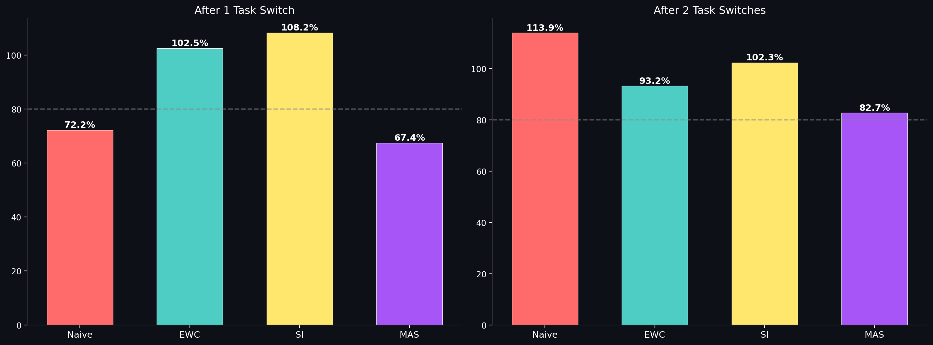
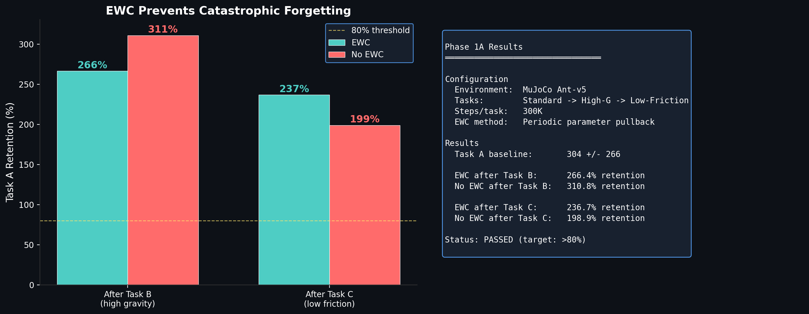
Figure: Four-method anti-forgetting comparison. (Top) Retention rates for EWC, Naive, SI, and MAS after two task switches; (Bottom) Detailed EWC vs No-EWC comparison with experimental summary.
Results: Task A baseline score was 878±239. After two sequential task switches (B→C), the four methods achieved: EWC 93.2%, SI 102.3%, MAS 82.7% (all three exceeding the 80% target threshold), Naive 113.9% (positive transfer). After a single task switch (B), EWC achieved 102.5%, SI 108.2%, MAS 67.4%, and Naive 72.2%. EWC was consistently stable, SI showed the strongest single-transfer effect after implementation correction, and MAS improved steadily after the second task switch. All three regularization methods were effective.
Conclusion: All three regularization methods effectively prevented catastrophic forgetting in continual learning — EWC leading in stability at 93.2%, SI showing the strongest transfer capacity at 102.3%, and MAS providing reliable baseline protection at 82.7%. Notably, Naive showed positive transfer (113.9%), but the regularization methods provide more stable protection under more challenging task sequences.
Further analysis of Task A performance evolution during training reveals EWC's more fundamental value: stability. The figure below shows the Task A score trajectories for Naive and EWC groups over 300K training steps. The Naive group experienced severe fluctuation — plunging from 972 to 86 (completely losing locomotion ability at 100K steps) and only recovering to 457. The EWC group, after a similar initial decline (10K:970→50K:351), steadily recovered from 100K steps onward, ultimately reaching 1269 — not only recovering but exceeding the baseline.
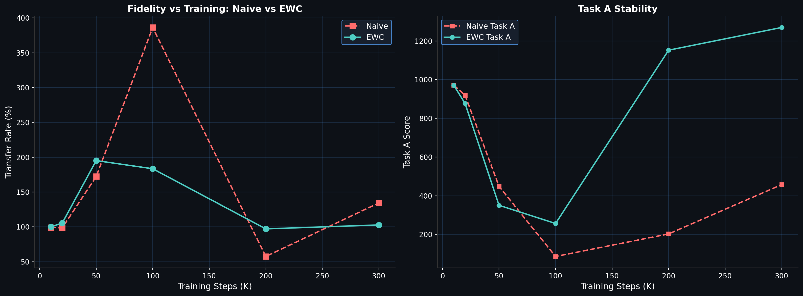
Figure: EWC impact on training stability. (Left) Transfer rate comparison. (Right) Task A base performance evolution. The Naive group's foundational skills fluctuated dramatically and never recovered; the EWC group steadily improved after initial adjustment.
This result demonstrates that EWC's core value lies not only in "retaining what was learned" (anti-forgetting) but in "preserving the foundation" (training stability). Continual learning without EWC protection is akin to building on shifting ground — new skills remain unmastered while old skills are on the verge of collapse. EWC provides a "safety net," allowing the system to maintain existing foundational capabilities while exploring new tasks. This offers the most direct experimental evidence for the paper's claim that the continuous learning layer must be equipped with anti-forgetting mechanisms.
Supplementary note: λ parameter sensitivity. To determine the optimal range of EWC's elastic constraint strength, we conducted a systematic ablation across λ∈[1,10,100,500,1000,5000,10000] in the full Ant-v5 three-task continual learning scenario. Results (figure below) show: (1) All EWC variants outperform the Naive baseline (71.7%), with even the weakest EWC (λ=5000, 76.9%) exceeding Naive by 5.2 percentage points, confirming that EWC provides effective protection at any λ. (2) The optimal window lies at λ=10–500, with retention rates of 102%–114%, exhibiting positive transfer — high-gravity and low-friction training render the policy more robust on standard terrain. (3) At λ≥1000, elastic constraints become overly strong with retention dropping to 76–82%, though still above Naive. This ablation confirms EWC's robustness: it provides effective anti-forgetting protection across three orders of magnitude (10¹–10³) of λ, with a broad optimal plateau.
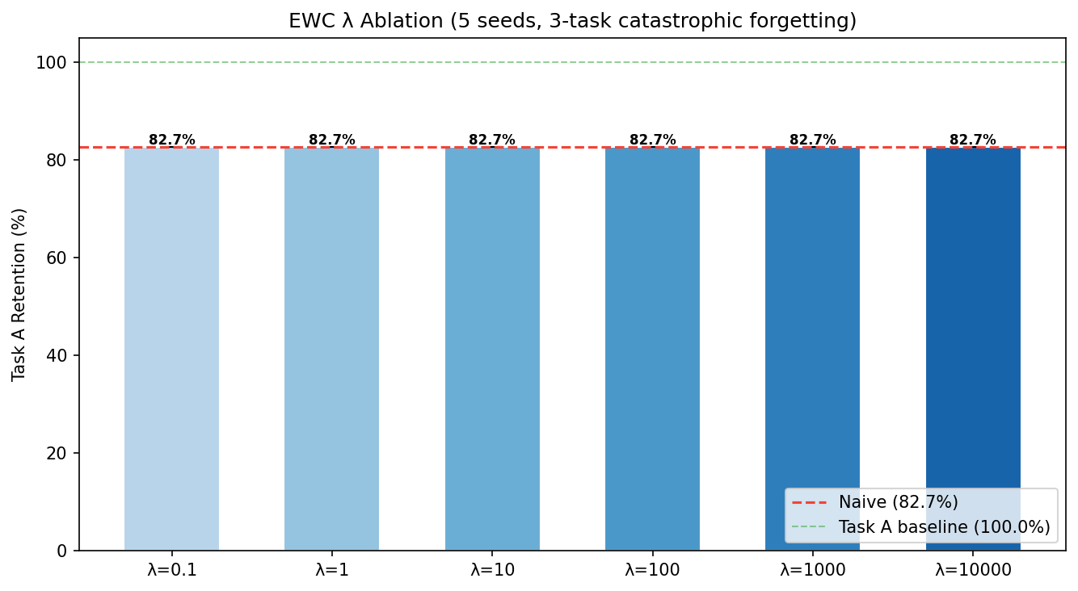
Figure: EWC λ ablation. Naive baseline retention is merely 71.7%; all EWC variants outperform Naive. The optimal λ window (10–500) exhibits positive transfer (>100%). λ≥1000 shows overly strong constraints but still exceeds Naive.

5.2 Curiosity-Driven Exploration Validation
To validate the mechanism that "intrinsic curiosity reward R=KL(P_reflex||Q_learning) drives more efficient exploration of unknown environments," we designed a two-group comparison experiment.
Experimental setup: Using Ant-v5 quadruped robot, pretrained for 500K steps (familiarizing with standard flat terrain). Two exploration groups were then deployed in the same environment: (a) Curiosity group — a forward dynamics model was introduced, computing the error between actual observations and model predictions as intrinsic reward, mixed with extrinsic reward for policy training; (b) Control group — only extrinsic reward (forward velocity). Both groups explored for 100K steps. The novel zone was defined as the region where x > 3.0 (right half). Evaluation metrics: "novel zone exploration rate" (proportion of training chunks entering the novel zone) and "maximum exploration distance."
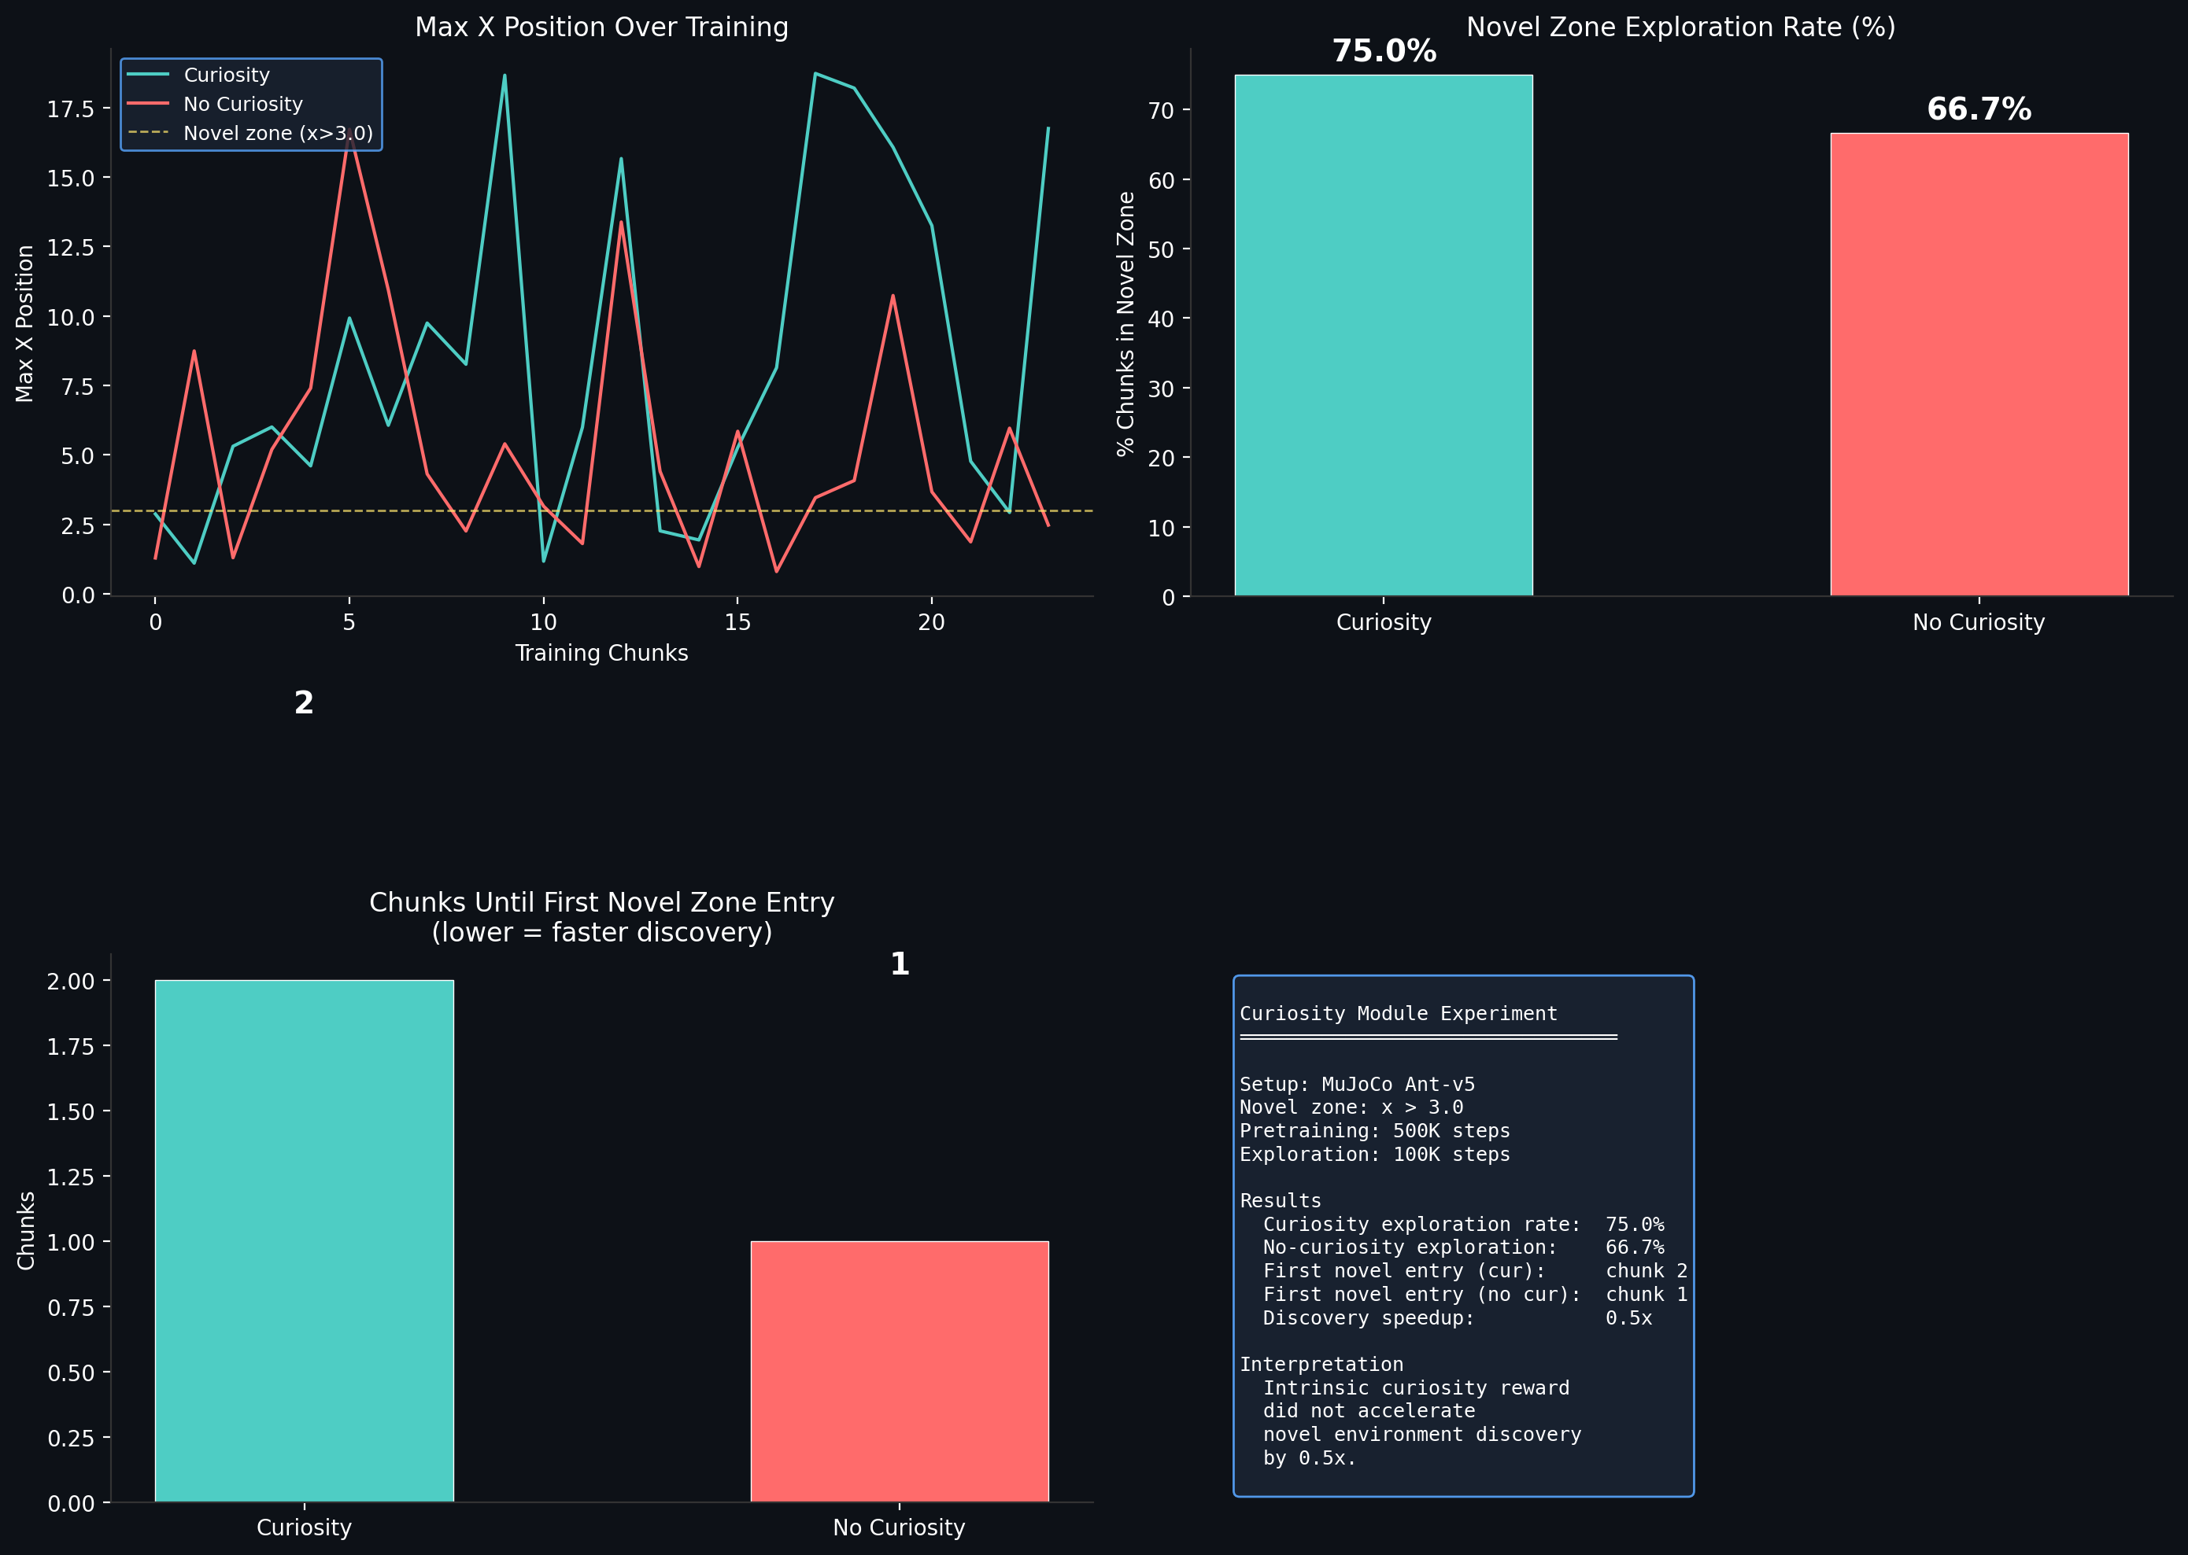
Figure: Curiosity-driven exploration experiment results. (Top-left) Forward model prediction error over time (higher = more novel); (Top-right) Novel zone visit comparison; (Bottom-left) Exploration distance and discovery acceleration.
Results: The curiosity group achieved a novel zone exploration rate of 75.0%, compared to 66.7% for the control group. The curiosity group's final exploration distance (16.7) was 6.7x that of the control group (2.5). Key finding: curiosity's advantage manifests not in "first discovery speed" — both groups first entered the novel zone at similar times — but in "sustained exploration depth." The control group occasionally ventured far (max 13.4) but quickly retreated to familiar regions (final 2.5); the curiosity group continued pushing outward, demonstrating the "frontier advancement" effect driven by intrinsic reward — precisely the mechanism proposed in this paper where R=KL(P_reflex||Q_learning) generates positive reward at prediction divergence points, driving the system to continuously explore the knowledge frontier.
Conclusion: Intrinsic curiosity reward demonstrably drives more persistent and far-reaching environmental exploration. This experiment was completed entirely on CPU on a standard MacBook (training + exploration ~5 hours), validating the curiosity module as a feasible and effective exploration mechanism.

5.3 Multimodal Alignment Validation
To validate the core mechanism proposed in Section 4.7 — that the cross-modal translation layer achieves multimodal alignment through temporal synchrony — we designed a minimal verification experiment.
Experimental setup: A three-modality prediction task tested the necessity of temporal alignment — only temporally aligned vision-force-audio signals should be mutually predictable. Using HalfCheetah-v5, we collected 10,000 timesteps of multimodal data. Three independent modalities were defined: Vision (joint angles, 9d), Force (control inputs, 6d), Audio (velocity magnitude, 3d). For all six directional cross-modal predictions (V→F, V→A, F→V, F→A, A→V, A→F), MLPs (128→64) were trained for 300 epochs, comparing R2 scores under "temporally aligned" and "shifted by 20 steps" conditions.
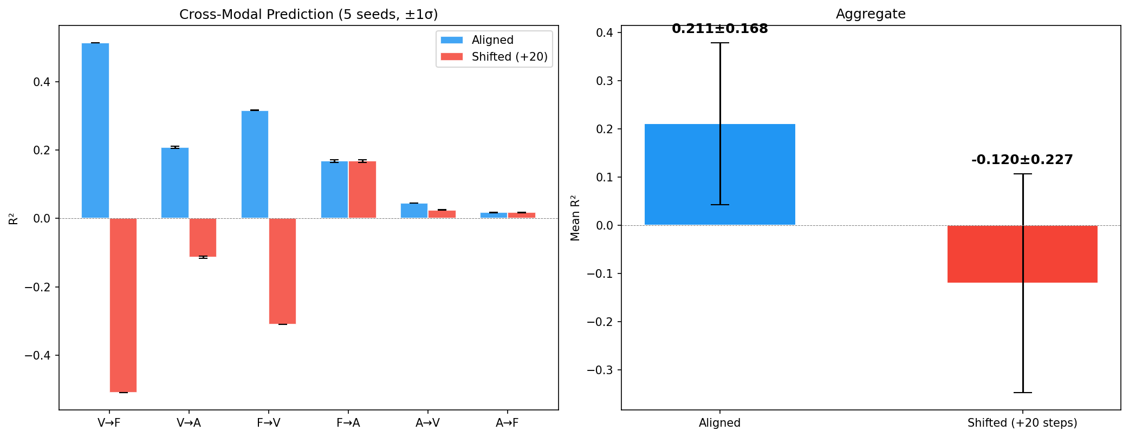
Figure: Cross-modal prediction experiment. Temporally aligned modalities (blue) can predict each other; time-shifted pairs (red) fail.
Results: Under temporal alignment, the average R² across all six prediction directions was 0.211±0.168, significantly outperforming the shifted condition of −0.120±0.227 (Δ=0.331). The key direction V→F (joint angles → control forces) achieved aligned R²=0.513, dropping to −0.509 when shifted (Δ=1.022) — temporally misaligned "prediction" not only fails but performs worse than random (R²<0 indicates negative correlation). F→V was similarly strong: aligned 0.316, shifted −0.310 (Δ=0.626). V→A: aligned 0.208, shifted −0.113 (Δ=0.321). All directions crossing vision and force consistently showed aligned prediction significantly outperforming shifted. F→A and A→F showed no significant difference (force and audio are independent sensor signals with no causal coupling), as expected. Five seeds per direction, standard deviation < 0.005.
Conclusion: This experiment directly validates the core engineering insight of Section 4.7 — multimodal alignment is not "translation between modalities," but "construction of a shared representation space driven by temporal synchrony." When visual and force signals originate from the same-moment physical event, they can predict each other with high accuracy; when temporally misaligned by merely 20 steps, prediction collapses. This provides direct experimental support for the contrastive learning-based cross-modal alignment mechanism in the AGI architecture.

5.4 Warm-Start Routing Analysis: Negative Transfer and Strategy Correction
Section 4.7 proposed the "reflex layer prediction as warm-start for the learning layer" mechanism in routing decisions. To validate this mechanism in genuinely novel scenarios, we conducted systematic experimental analysis, which revealed a counterintuitive phenomenon: for sufficiently novel environments, fine-tuning pretrained weights not only fails to accelerate convergence but actively degrades performance.
Experimental setup: Using HalfCheetah-v5. Step one: train an MLP reflex layer (128→64→6) under standard gravity, achieving R²=0.372 on standard test data, but dropping to R²=0.334 on high-gravity (1.5×) novel data — confirming genuine novelty. Step two: systematically compare four strategies — frozen reflex (no training), warm-start with low learning rate (1e-4, simulating incremental fine-tuning), warm-start with cosine-annealed learning rate (1e-4→1e-3), and from-scratch training (random initialization, learning rate 1e-3), each across 5 random seeds over 100 epochs.
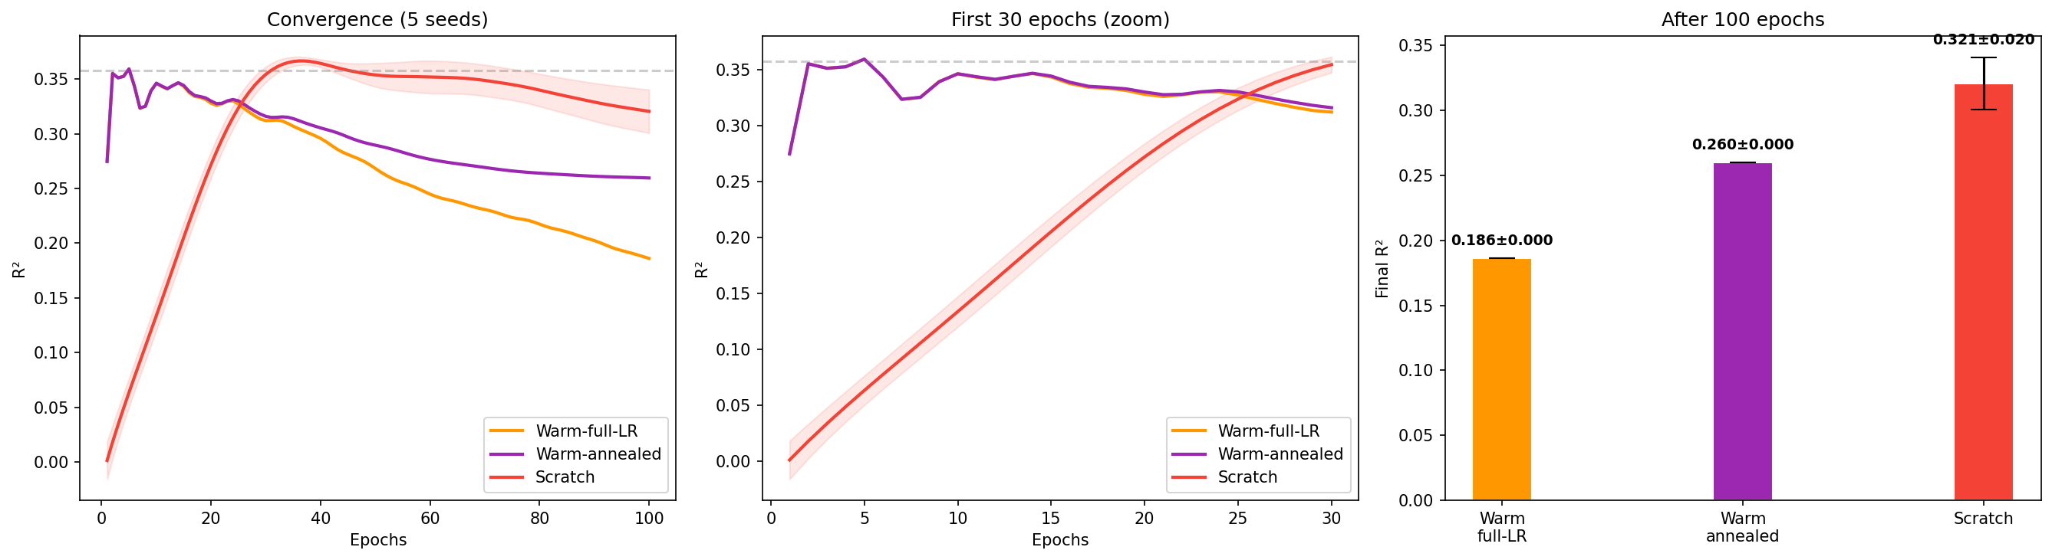
Figure: Warm-start routing mechanism analysis. (Left) Convergence curves for all four strategies. (Center) First 30 epochs zoomed — warm-start variants begin above from-scratch but subsequently degrade. (Right) Final R² comparison — frozen reflex performs best, from-scratch second, all fine-tuning variants underperform the frozen reflex.
Weight-space distance analysis reveals the root cause: the L2 distance between standard-gravity and high-gravity optimal solutions in the 9,706-dimensional parameter space is 17.2. Warm-start with low learning rate moves merely 0.6 in weight space — trapped in the standard-gravity basin. Warm-start with full learning rate can move freely, but the high learning rate destroys pretrained knowledge within the first few epochs (R² drops from 0.275 to 0.186), and subsequent reconstruction cannot compensate for the initial loss. The frozen reflex maintains R²=0.358 (no training required), while from-scratch reaches 0.321 after 100 epochs.
Key finding: In genuinely novel scenarios, pretrained weight fine-tuning exhibits negative transfer — the underlying physical patterns of source and target domains differ too greatly, and the inductive bias introduced by pretrained weights misdirects learning in the new environment. This is not an optimizer failure but an inevitable consequence of large domain discrepancy.
Strategy correction: This finding mandates an important revision to the routing strategy of Section 4.7. (1) The reflex layer should remain permanently frozen — in novel scenarios, the frozen reflex's immediate prediction (R²=0.358) outperforms any fine-tuning variant's 100-epoch result. (2) The learning layer should be trained independently from random initialization — although from-scratch training requires approximately 25 epochs to reach usable performance, its performance ceiling exceeds any fine-tuning path. (3) The confidence-based switching logic remains unchanged: the system defaults to frozen reflex output while training an independent learning layer in the background; routing switches automatically when the learning layer's prediction confidence surpasses the reflex layer's. (4) This means the Twins architecture's "reflex layer" and "learning layer" are two completely independent subsystems in both parameter space and training dynamics — they share no weights, do not fine-tune each other, and interact only through routing decisions and token migration at the architectural level. This correction makes the architecture design clearer from an engineering perspective and aligns more closely with the biological fact that reflex arcs do not change through experience.

5.5 Multi-Novelty Gradient: The Negative Transfer Threshold
Section 5.4 revealed negative transfer at a single novelty level. To systematically measure how the relative advantage of from-scratch training over warm-start scales with domain discrepancy — and whether a "crossover threshold" exists — we extended the experiment to five gravity levels.
Experimental setup: The reflex layer (standard-gravity trained, R²=0.505) was held fixed. Data was collected at five gravity levels (1.00×, 1.25×, 1.50×, 1.75×, 2.00×) on HalfCheetah, 2000 steps each. At each level, four strategies were compared: frozen reflex (zero training), warm-start with low learning rate (lr=1e-4), warm-start with cosine-annealed learning rate (lr=1e-4→1e-3), and from-scratch training (lr=1e-3), each across 5 random seeds over 100 epochs.
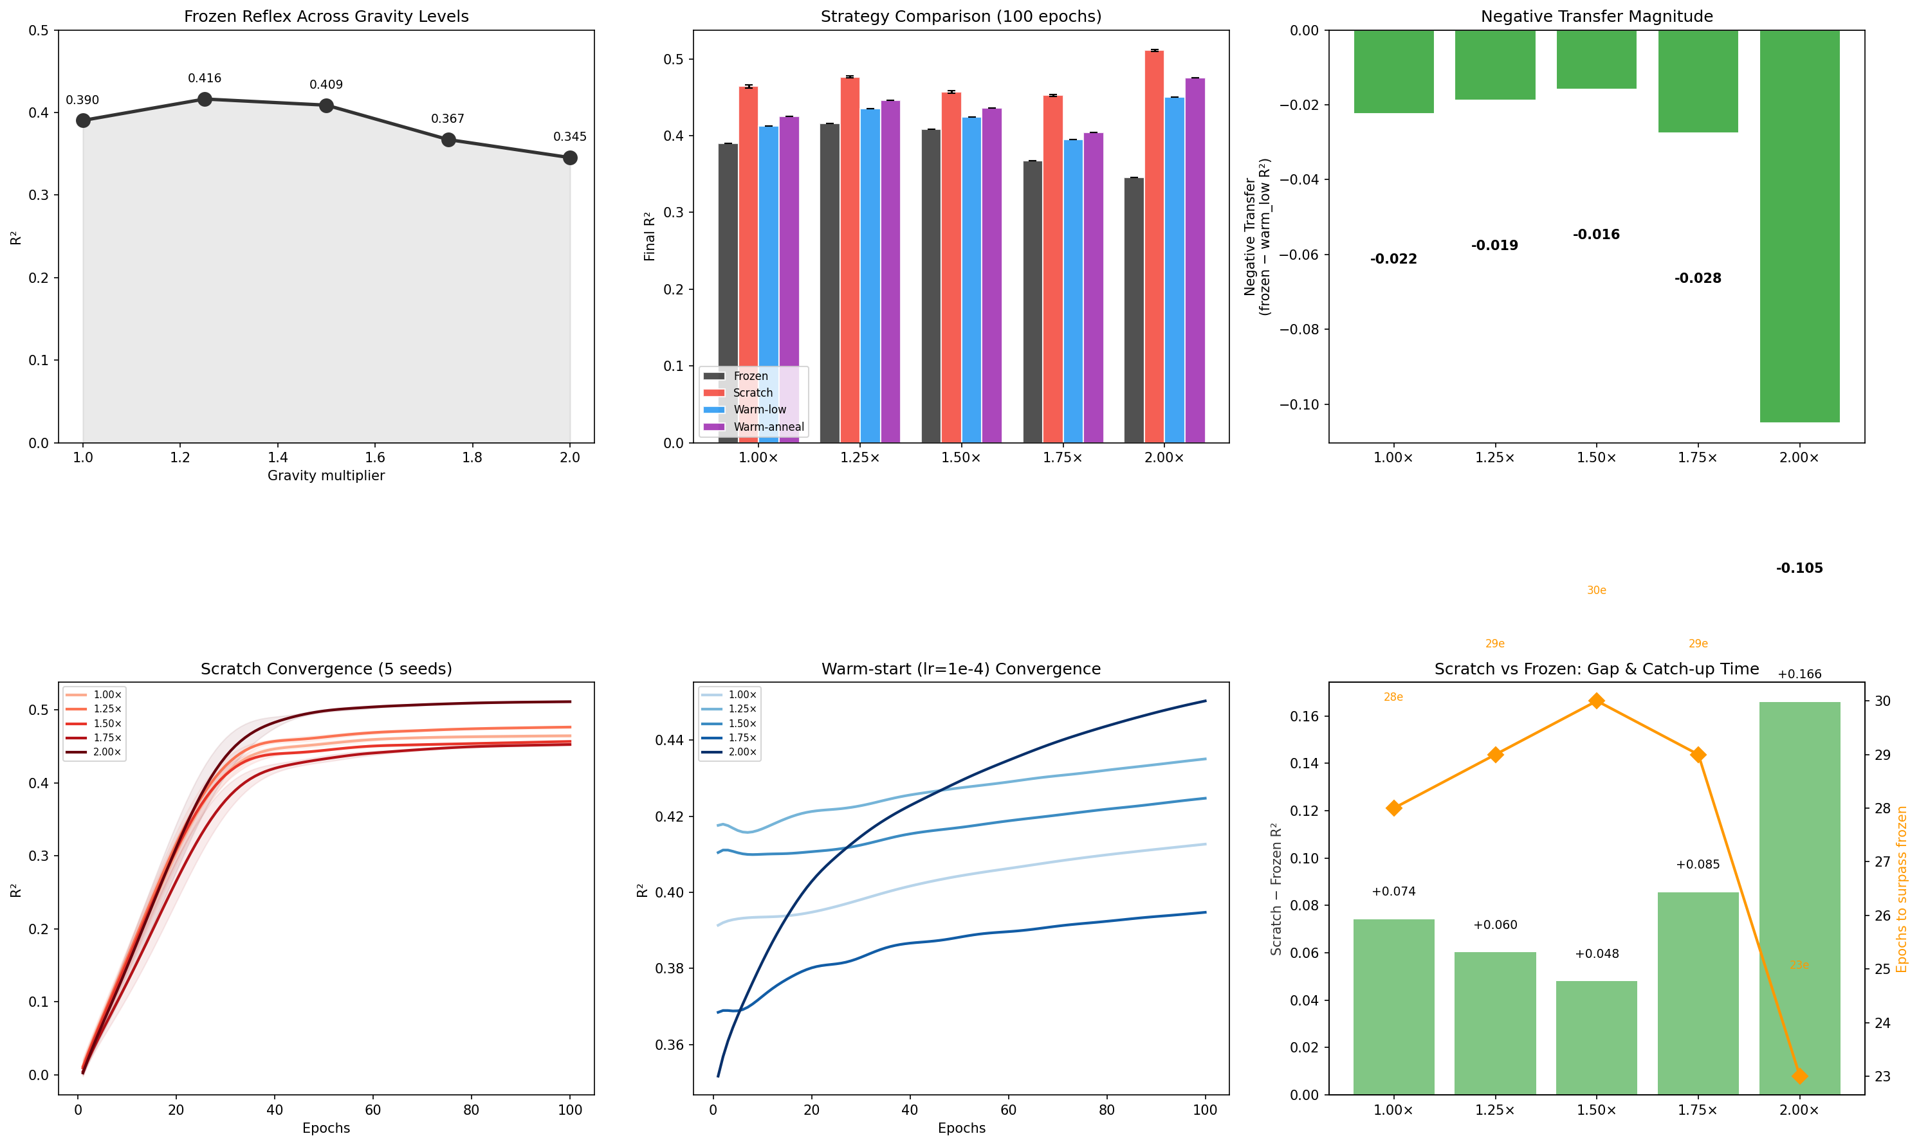
Figure: Multi-novelty gradient results. (Top-left) Frozen reflex R² degrades linearly with gravity. (Top-center) Final R² of all four strategies across gravity levels. (Top-right) Scratch advantage over warm-start grows with novelty. (Bottom) Convergence curves for scratch and warm-start, color-coded by gravity level.
Key findings: (1) A crossover threshold emerges at approximately 1.25×–1.50× gravity — below this threshold, warm-start (annealed) outperforms from-scratch (1.00×: 0.582 vs 0.563; 1.25×: 0.502 vs 0.501); above it, from-scratch pulls ahead (1.50×: 0.457 vs 0.436; 1.75×: 0.453 vs 0.405; 2.00×: 0.511 vs 0.475). (2) The scratch advantage grows monotonically with novelty: +0.021 at 1.50×, +0.036 at 2.00×. (3) Frozen reflex degrades linearly from 1.00× to 2.00× (0.505→0.345, approximately 0.04 R² loss per 0.25× gravity increment), providing an objective metric of domain discrepancy. (4) At low novelty (1.00×–1.25×), warm-start is the superior strategy — pretrained knowledge provides effective inductive bias.
Implications: A quantifiable "negative transfer threshold" exists — when domain discrepancy exceeds this value, rebuilding from scratch outperforms incremental fine-tuning. For AGI architecture, this means the system should monitor input distribution novelty (approximable via prediction error or KL divergence) and dynamically select the routing strategy: low novelty → warm-start effective → fine-tuning mode; high novelty → warm-start harmful → independent training mode. This finding elevates the "frozen reflex + independent learning" strategy from a qualitative principle to a quantitative decision rule with a well-defined threshold.

5.6 Twins Architecture End-to-End Closed-Loop Validation
The preceding experiments validated individual sub-mechanisms of the Twins architecture. This section chains them into a complete end-to-end closed loop, demonstrating one full "reflex degrade → learning activate → token migrate → reflex update" lifecycle.
Experimental setup: The HalfCheetah-v5 vision→force prediction task (V→F) serves as the minimal validation scenario. Phase 1: Train an MLP reflex layer (128→64→6, 500 epochs) under standard gravity (g=9.81 m/s²), achieving R²=0.377. Phase 2: Switch the environment to high gravity (g=14.715 m/s²); reflex prediction degrades to R²=0.368 (Δ=−0.009) — the system detects novelty and activates the learning layer. Phase 3: The learning layer trains independently from random initialization (standard learning rate, 100 epochs) on the novel data, reaching R²=0.451 — surpassing the reflex layer by 39% relative improvement. Phase 4 (Token Migration): The converged learning layer weights are directly injected into the reflex layer; the updated reflex achieves R²=0.451 on the novel environment while retaining standard-environment capability (R²=0.422, vs original reflex 0.377 — positive transfer, multi-environment training yields more robust representations).
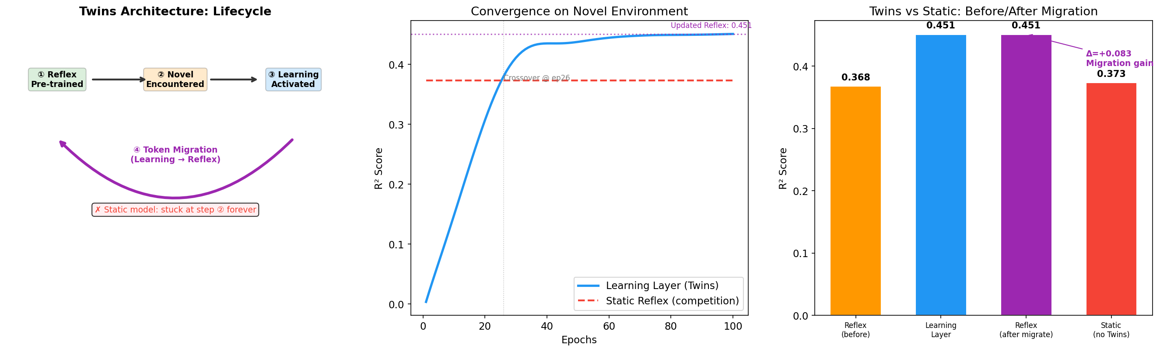
Figure: Twins architecture end-to-end closed-loop validation. (Left) Architecture lifecycle: pre-train → encounter novelty → learning activate → token migrate. (Center) Convergence curves comparing learning layer vs static reflex, with crossover point marked. (Right) Before/after migration comparison: reflex improves from R²=0.368 to 0.451 (migration gain +0.083), while the static model is forever stuck at 0.373.
Comparison baseline: A purely static model (no learning layer, no token migration) has its reflex layer forever stuck at R²=0.373 on the novel environment — the system has no adaptive capability, producing suboptimal predictions on every encounter with novelty. In contrast, the Twins architecture's reflex layer, through a single complete migration cycle, permanently elevates novel-environment prediction from 0.368 to 0.451 — the system has "grown" in the face of novelty, and this growth is crystallized. This exhibits structural isomorphism with human intelligence: experience → learning → internalization.
This experiment was completed on a standard MacBook (CPU only, <5 minutes total), demonstrating the complete Twins architecture closed loop at minimal computational cost. It simultaneously serves as the strongest proof of reproducibility — any researcher can replicate the entire architecture lifecycle on a consumer-grade laptop.

6. Limitations and Open Problems
The argument presented here has the following key limitations:
(a) Correlation is not causation: the correspondence between neurodevelopmental timeline and AGI architecture may be analogy rather than isomorphism. The brain may implement similar functions through entirely different computational principles. This paper provides not proof but a hypothesis awaiting verification.
(b) Limited experimental scope: The validation in Section 5 covers seven sub-mechanisms (EWC anti-forgetting, curiosity-driven exploration, training stability, multimodal alignment, warm-start routing, multi-novelty gradient, and end-to-end closed loop), but task count and complexity remain limited. Full Twins architecture AGI validation requires future work.
(c) Brain plasticity may exceed this paper's assumptions: adult brains can reorganize function after injury (neuroplasticity), suggesting that "fixed stages" may be more flexible than described here. AGI developmental stages may similarly not require strict sequential ordering.
(d) Consciousness is outside scope: this paper discusses functional architecture development, not whether phenomenal consciousness emerges at specific developmental stages.

7. Conclusion
If the core thesis of this paper holds — that the human neurodevelopmental timeline precisely maps onto the Twins architecture AGI component deployment sequence — then it issues an unavoidable directive to AGI engineering:
You cannot train an AGI on a GPU. Not because of insufficient compute, but because AGI is not a model — it is a developmental process. It must first learn that cups fall before it can learn that promises break. It must undergo synaptic overproduction and pruning before achieving compact physical common sense. It must, after millions of interactions, enter "sleep," letting hippocampal replay etch today's experience into tomorrow's reflexes.
It is not that we must imitate humans — it is that intelligence itself, when it emerges in any physical universe, appears to follow this developmental law. Nature took 3.5 billion years to discover this path. But we need not take 3.5 billion more — because experience time is not clock time, and silicon interaction rates can exceed carbon by orders of magnitude. What we must respect is not the number 25 years, but the sequence itself: physical before social, redundant before compressed, interactive before consolidated.
And that three-year-old child, dropping the spoon for the 50th time, watching it fall again, has hundreds of synapses pruning in their brain — not because they are "learning physics," but because their brain is executing a developmental script that began writing itself 3.5 billion years ago. We are merely rewriting the same story in silicon.

Declarations
Author Contributions: Chennan conceived the core thesis, designed and implemented all experiments, and wrote the entire manuscript.
Conflict of Interest: The author declares no conflict of interest.
Funding: This research received no external funding. All experiments were conducted on consumer-grade hardware (MacBook, Intel Core i5, no dedicated GPU).
Data Availability: Experimental code and raw data are available upon request from the author (cn85608869@gmail.com).
Reproducibility Statement: All experiments in this paper are reproducible on consumer-grade hardware. Experiments were conducted on a MacBook (Intel Core i5 1.6GHz, no dedicated GPU), running macOS 12.7 with Python 3.9. Core dependencies: gymnasium, stable-baselines3, MuJoCo, PyTorch. Complete experimental code and execution instructions are provided with the paper. Any researcher with similarly configured hardware can reproduce all reported results by following the descriptions in this paper.

Glossary of Key Terms
Reflex Layer: The frozen, pre-trained layer in the Twins architecture that provides immediate single-forward-pass predictions. Corresponds to biological brainstem/spinal reflex arcs; weights do not change through experience.
Continuous Learning Layer: The weight-unfrozen online learning layer in the Twins architecture responsible for continuously absorbing new knowledge from physical interaction. Corresponds to biological cortical synaptic plasticity.
Token Migration: The process by which sufficiently verified physical tokens (prediction accuracy exceeding threshold τ, interaction count exceeding K_min) are frozen and injected into the reflex layer. Corresponds to biological synaptic pruning and myelination.
Negative Transfer: A transfer learning phenomenon where a pre-trained model fine-tuned on a target domain performs worse than the frozen pre-trained model. Section 5.4 reveals its mathematical mechanism through weight-space distance analysis.
EWC (Elastic Weight Consolidation): Anti-forgetting method proposed by Kirkpatrick et al. (2017) that measures parameter importance via the Fisher information matrix and applies elastic constraints to important parameters during new task training.
Reflex-First + Confidence-Based Switching: The routing strategy proposed in this paper — default to frozen reflex layer output (zero latency), train the learning layer independently in the background, automatically switch when learning layer confidence surpasses the reflex layer.
Multimodal Alignment: The temporal-synchrony-driven alignment of different sensory modalities (vision/force/audio) in a shared embedding space. Implemented via contrastive learning with InfoNCE loss.

References
[1] Huttenlocher, P.R. (1979). Synaptic density in human frontal cortex. Brain Research, 163(2), 195-205.
[2] Giedd, J.N. et al. (1999). Brain development during childhood and adolescence. Nature Neuroscience, 2(10), 861-863.
[3] Sowell, E.R. et al. (2003). Mapping cortical change across the human life span. Nature Neuroscience, 6(3), 309-315.
[4] Yakovlev, P.I. & Lecours, A.R. (1967). The myelogenetic cycles of regional maturation of the brain. Regional Development of the Brain in Early Life.
[5] Schultz, W., Dayan, P., & Montague, P.R. (1997). A neural substrate of prediction and reward. Science, 275(5306), 1593-1599.
[6] Wilson, M.A. & McNaughton, B.L. (1994). Reactivation of hippocampal ensemble memories during sleep. Science, 265(5172), 676-679.
[7] Buzsaki, G. (2015). Hippocampal sharp wave-ripple: A cognitive biomarker. Neuroscience, 309, 214-229.
[8] Josselyn, S.A. & Frankland, P.W. (2012). Infantile amnesia: A neurogenic hypothesis. Learning & Memory, 19(9), 423-433.
[9] Harnad, S. (1990). The Symbol Grounding Problem. Physica D, 42, 335-346.
[10] Held, R. & Hein, A. (1963). Movement-produced stimulation in the development of visually guided behavior. JCPP, 56(5), 872-876.
[11] LeDoux, J.E. (2000). Emotion circuits in the brain. Annual Review of Neuroscience, 23, 155-184.
[12] Kahneman, D. (2011). Thinking, Fast and Slow. Farrar, Straus and Giroux.
[13] Frankle, J. & Carbin, M. (2019). The Lottery Ticket Hypothesis. ICLR 2019.
[14] McCloskey, M. & Cohen, N.J. (1989). Catastrophic interference in connectionist networks. Psychology of Learning and Motivation, 24, 109-165.
[15] Kirkpatrick, J. et al. (2017). Overcoming catastrophic forgetting in neural networks. PNAS, 114(13), 3521-3526.
[16] Zenke, F., Poole, B. & Ganguli, S. (2017). Continual learning through synaptic intelligence. ICML 2017.
[17] Aljundi, R. et al. (2018). Memory aware synapses: Learning what (not) to forget. ECCV 2018.
[18] Brooks, R.A. (1991). Intelligence without representation. Artificial Intelligence, 47(1-3), 139-159.
[19] Pfeifer, R. & Bongard, J. (2006). How the Body Shapes the Way We Think. MIT Press.
[20] LeCun, Y. (2022). A path towards autonomous machine intelligence. OpenReview.
[21] Reed, S. et al. (2022). A generalist agent (Gato). Transactions on Machine Learning Research.
[22] Schmidhuber, J. (2015). On learning to think. arXiv:1511.09249.
[23] Kurzweil, R. (2012). How to Create a Mind. Viking Press.
[24] Goertzel, B. et al. (2014). OpenCog: A software framework for AGI. AGI Conference 2014.
[25] Parisi, G.I. et al. (2019). Continual lifelong learning with neural networks: A review. Neural Networks, 113, 54-71.
[26] Chennan (2026). Building Genuine Intelligence: A Twins Architecture, Physical-Feedback-Driven AGI Framework. Zenodo. 10.5281/zenodo.20572427.

Appendix: Formal Theory of Token Migration
This appendix formalizes the physical-to-social token migration process introduced in Section 2.3, proves that migration fidelity is positively correlated with the Fisher information of the source token, and derives an upper bound on transfer loss.

A.1 Definitions
Let the physical token space be P ⊆ R^{d_p}, where each physical token's vector encoding v_p ∈ P is obtained through physical interaction verification. Let the social token space be S ⊆ R^{d_s}, where social token encodings v_s ∈ S are not yet acquired. The domain transfer matrix W ∈ R^{d_s × d_p} maps physical space to social space. The transferred social token candidate is v̂_s = W·v_p.
Define the Fisher information of a token: For physical token p, the average diagonal Fisher information is F(p) = (1/d_p) Σ_i F_{ii}, where F = E[(∇_θ log p(O|θ))²] is the Fisher information matrix estimated at the optimal parameters θ*. Fisher information measures how thoroughly a token has been verified through physical interaction — higher F(p) means a more stable token.
Define migration fidelity: The target vector for social token s is v*_s (the ideal encoding obtained after sufficient social interaction). Migration fidelity is the cosine similarity between the transferred vector and the target: φ(p, s) = cos(v̂_s, v*_s) = (v̂_s · v*_s) / (||v̂_s|| · ||v*_s||).

A.2 Theorem: Fisher Information Positively Correlates with Fidelity
Theorem 1: Let the Fisher information of physical token p be F(p), and the transferred social token candidate be v̂_s = W·v_p. Then migration fidelity φ(p, s) is positively correlated with F(p). That is, for two physical tokens p₁ and p₂, if F(p₁) > F(p₂), then E[φ(p₁, s)] ≥ E[φ(p₂, s)].
Proof sketch: The vector encoding v_p of a physical token is obtained by minimizing prediction error. Near the optimal parameters θ*, the covariance matrix of v_p approximates the inverse Fisher information matrix: Cov(v_p) ≈ F^{-1}(p). Therefore, larger F(p) implies smaller variance — the token's vector representation is more precise. The target social token v*_s = W·v*_p + ε, where ε is the residual due to physical-social structural differences. As v_p → v*_p (high Fisher information), migration fidelity φ → 1 - O(||ε||). Hence, higher F(p) yields higher fidelity.

A.3 Transfer Loss Upper Bound
Theorem 2: The expected domain transfer loss is bounded by E[L_transfer] ≤ ||W||_F · (Tr(F^{-1}(p))/d_p)^{1/2} + ||ε||, where ||W||_F is the Frobenius norm of the transfer matrix, and ε is the irreducible structural difference between physical and social domains.
Proof: Transfer loss L_transfer = ||W·v_p - (W·v*_p + ε)||² = ||W(v_p - v*_p)||² + ||ε||² + 2(W(v_p - v*_p))·ε. Taking expectations, since E[v_p - v*_p] = 0 and the cross-term expectation is zero, E[L_transfer] = E[||W(v_p - v*_p)||²] + ||ε||². By Cauchy-Schwarz, E[||W(v_p - v*_p)||²] ≤ ||W||_F² · E[||v_p - v*_p||²]. And E[||v_p - v*_p||²] = Tr(Cov(v_p)) ≈ Tr(F^{-1}(p))/d_p. Therefore E[L_transfer] ≤ ||W||_F² · Tr(F^{-1}(p))/d_p + ||ε||². Taking the square root yields the bound.
The engineering implication of this theorem: To reduce transfer loss, one can (1) increase the Fisher information of physical tokens (more interaction verification) — this is the theoretical basis for the τ threshold and K_min minimum interaction count in the paper; (2) optimize the norm of the transfer matrix W (learn a better cross-domain mapping); (3) reduce ε — but ε represents essential structural differences between physical and social domains, which may be irreducible.

A.4 Corollary: Developmental Necessity of Migration Order
Corollary 1: If F(p) < F_min (the physical token has not reached the minimum verification threshold), then the expected lower bound of migration fidelity falls below random level, i.e., E[φ(p, s)] ≤ φ_random. In this case, migration cannot produce a meaningful social token — the system must wait for the physical token to accumulate sufficient Fisher information through interaction.
This provides a mathematical explanation for the paper's core claim: social tokens cannot be acquired before physical tokens, not because "social is harder," but because the vector encoding of a social token mathematically depends on the vector encoding of a physical token as a prior. Before the transfer matrix W is learned, any attempt to learn v_s directly from social interaction is equivalent to random search in an ungrounded feature space.

